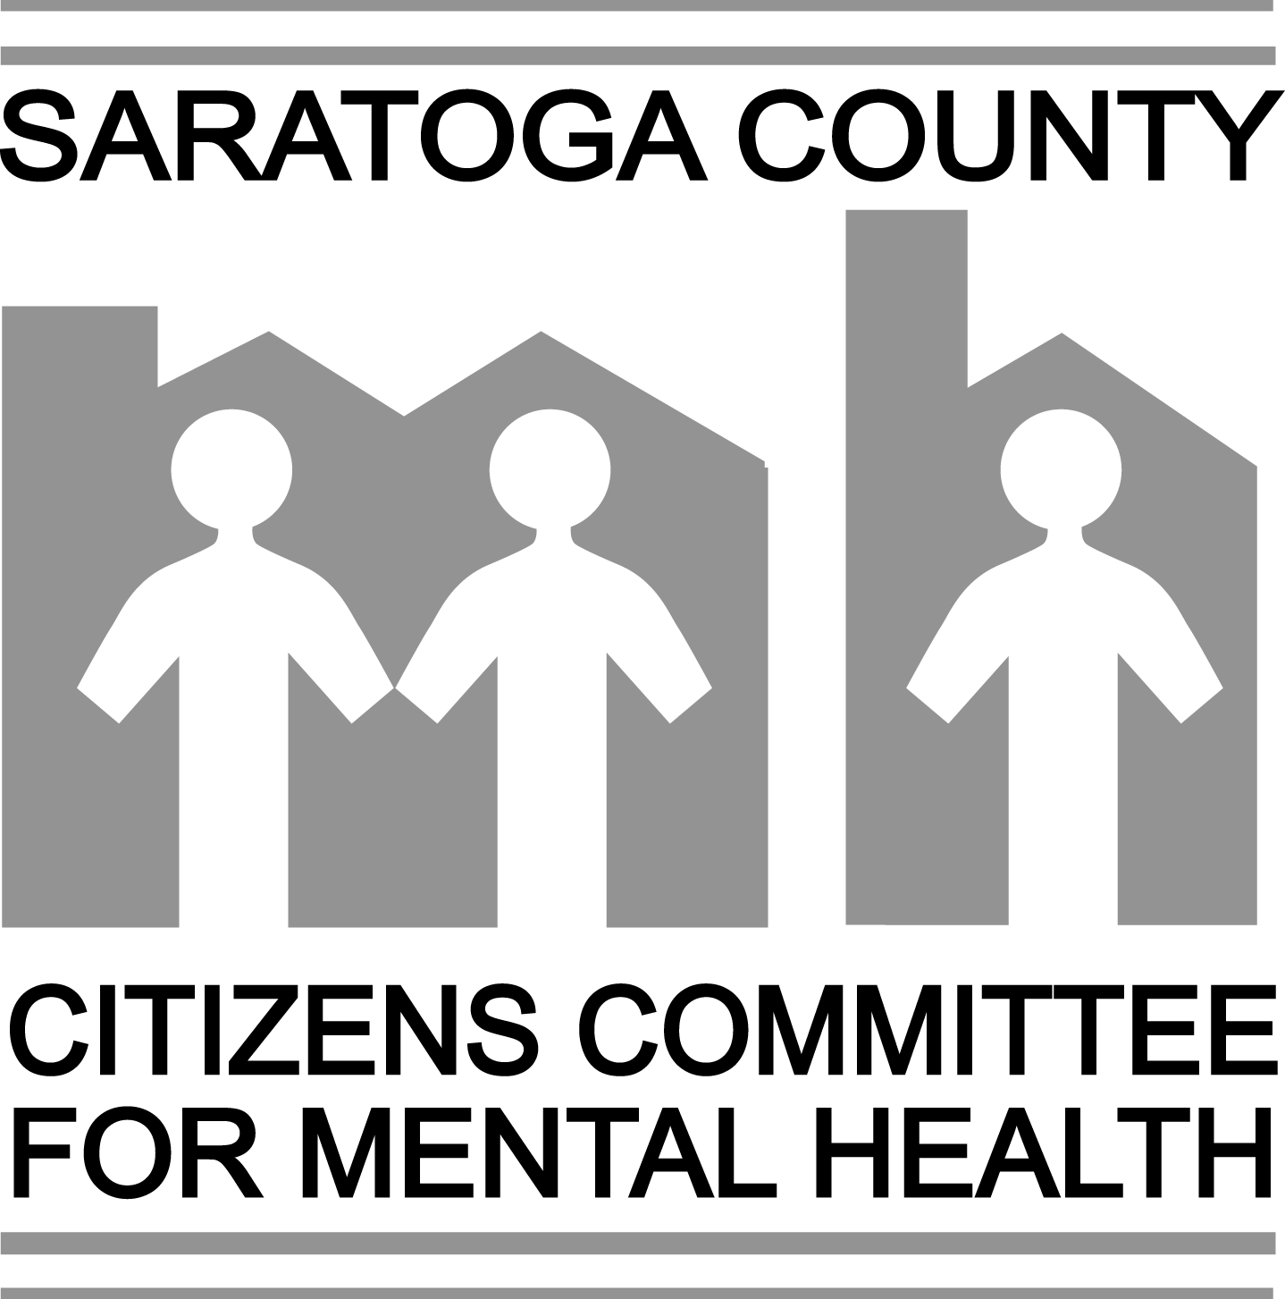
Saratoga County Citizens Committee for
Mental Health

“Citizen of the Year” Nominating Form

The Citizen of the Year Award recognizes people and organizations that directly or indirectly provided support to the mental health community or consumers in Saratoga County. SCCCMH honors one worthy nominee annually.
Criteria: A nominated individual or organization has a record of serving the mental health community in Saratoga County in one or more of the following ways:
1. The nominee promoted a better understanding of mental health issues, reducing stigma associated with mental illness.
2. The nominee managed personal mental illness with courage and grace, promoting a better understanding of mental health issues and reduction of stigma associated with mental illness through contributions to the community.
3. Through work in the mental health community, the nominee has created or improved community programs to foster a supportive, caring environment for individuals with mental illness.
4. The nominee’s community contributions have brought greater, more positive awareness to mental health issues.

PLEASE NOTE: TO BE CONSIDERED FOR MAY RECOGNITION, NOMINATIONS ARE ACCEPTED FROM DECEMBER 1ST TO FEBRUARY 1ST .
DATE:
Nominee Information (Please print or type):
NAME:
ADDRESS
HOME PHONE: OTHER:
EMAIL:
Describe in detail, and with examples, how the nominee meets one or more of the above criteria (specify the criteria by number above). Use a separate sheet if more room is needed.

Information about the person(s) making this nomination:
YOUR NAME(S):
RELATIONSHIP TO NOMINEE, IF ANY:
ADDRESS:
HOME PHONE: OTHER:
EMAIL:
Mail this form to: SCCCMH, COY Committee, P. O. Box 820, Saratoga Springs, NY 12866
Or E-mail to SCCCMH Vice Chair, Susann Getsch: sgetsch1@nycap.rr.com
(Rev. January 2010)

