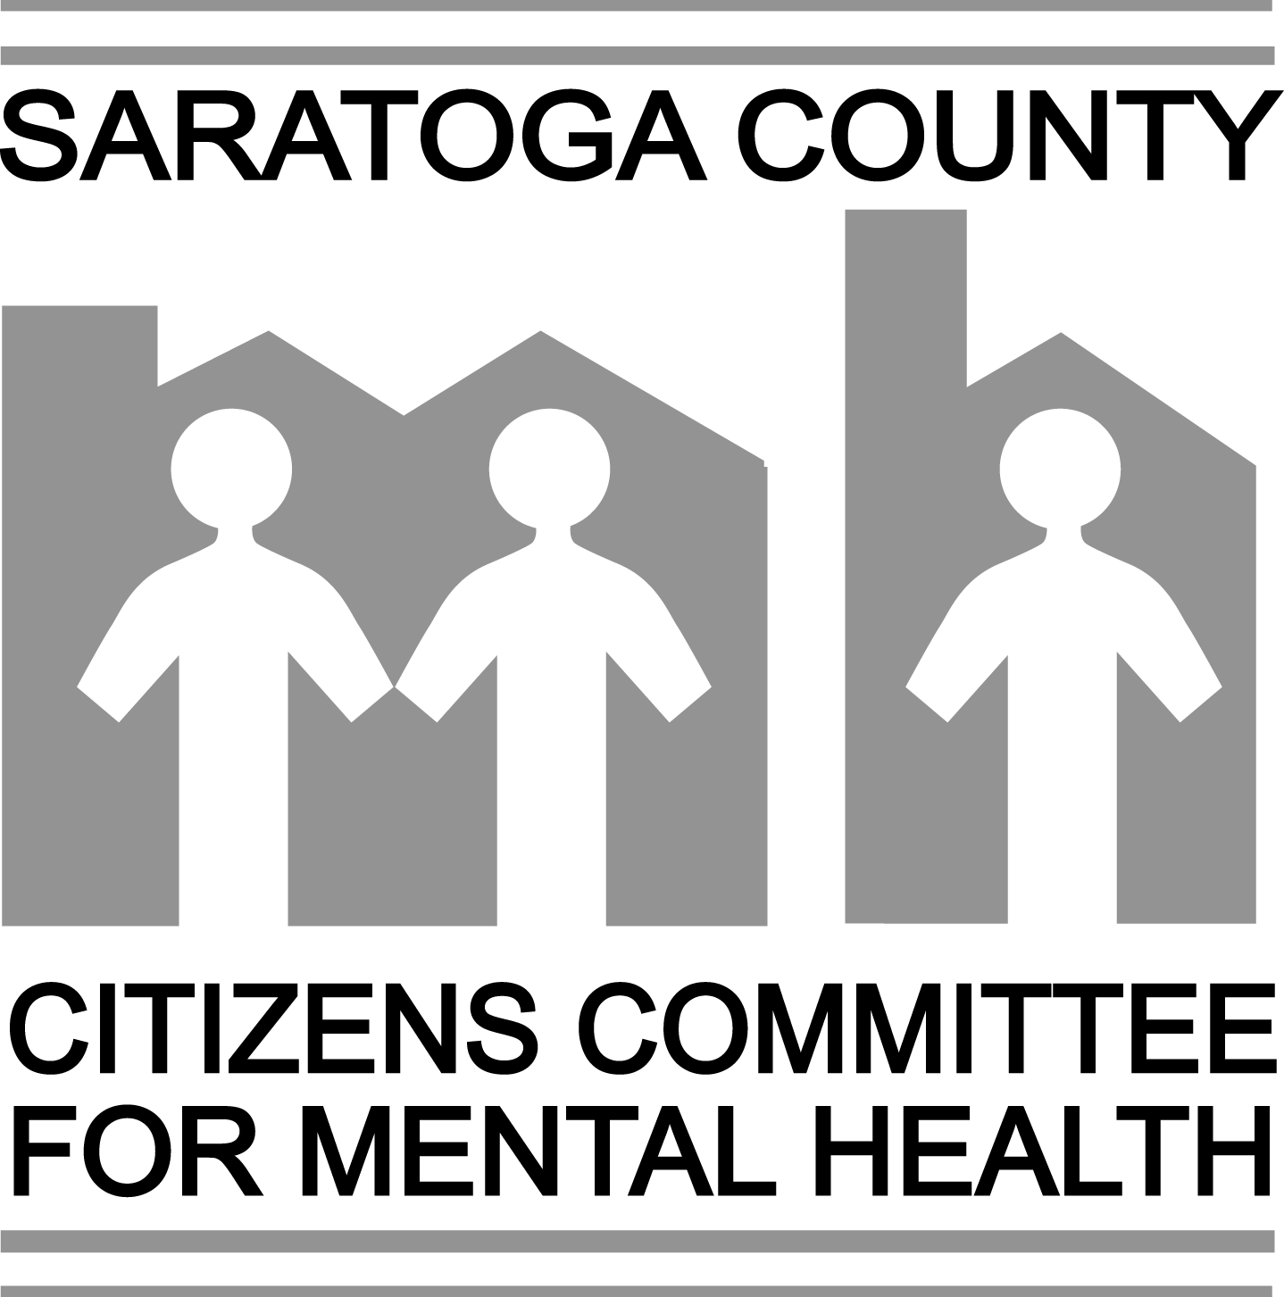
To make a donation, please mail this form and payment to:

Saratoga County Citizens Committee for Mental Health
P. O. Box 820
Saratoga Springs, NY 12866

Date: ______________________ (Please PRINT all information clearly.)

Enclosed is my check for $______________, payable to SCCCMH.

My name: _____________________________________________________________________

Address: ______________________________________________________________________

Phone: __________________________________Email:________________________________

If you would like to designate your gift as a memorial or honorarium, please complete the information below:

⁬ Gift in memory of: ____________________________________________________________
(Name of deceased)

⁬ Gift in honor of: ____________________________________________________________
(Name of individual)

Please indicate the name and address of the person to receive the gift acknowledgement card:

Name: __________________________________________________________________

Address: ________________________________________________________________

_________________________________________________________________

Indicate how you would like the acknowledgement card signed (e.g., your first and last name, Mr. and Mrs., etc.).

_____________________________________

The SCCCMH is a non-profit, charitable organization. Donations are tax deductible.

(Rev. January 2010)

